Data Visualization Part 1
Homework
02/05/2026
Priya Shahi
Github: https://github.com/ShahiPriya1/Reproducibility-Class

Role of ggplot: - Basic plotting function
-Used for layering
- Data positioning adjustment
R-Code
install.packages("ggplot2")
or
install.packages("tidyverse") #also include ggplot2 and other packages

library(tidyverse)
mtcars
#The line is in the top of the points
ggplot(mtcars, aes(x=wt, y=mpg)) +
geom_point() +
geom_smooth(method = lm, se = FALSE)
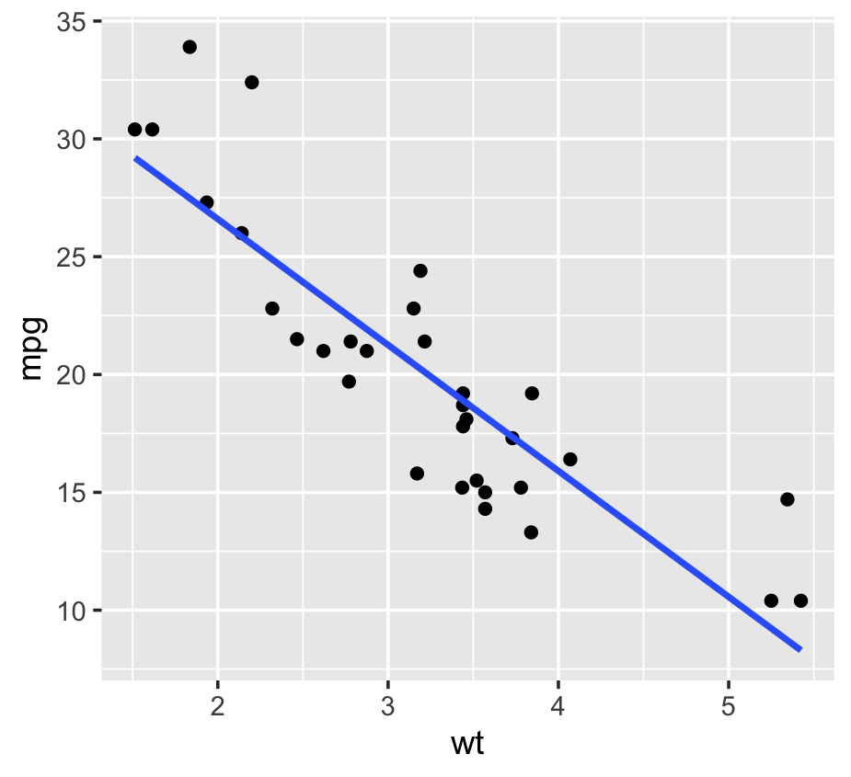

#the points are on the top
ggplot(mtcars, aes(x=wt, y=mpg, sizw+wr)) +
geom_smooth(method = lm, se = FALSE) +
geom_point() +
xlab("Weight(tons)") +
ylab("Miles per gallon")
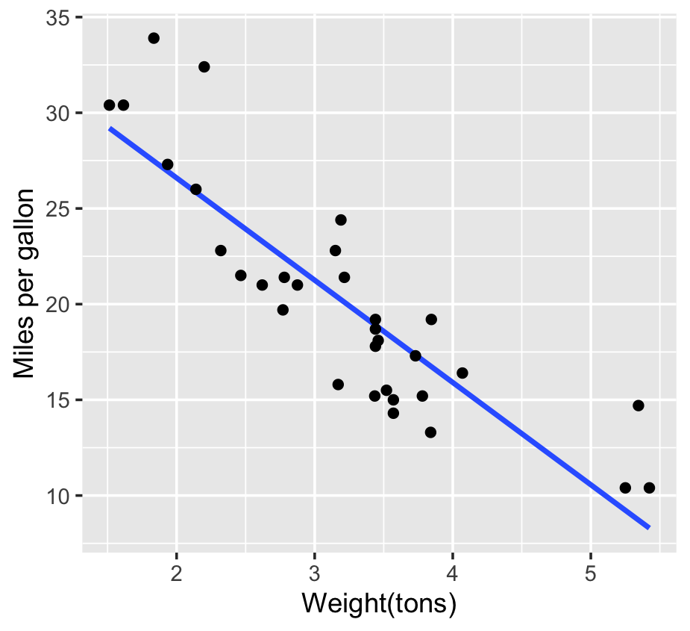

#Points acc to weight
ggplot(mtcars, aes(x=wt, y=mpg)) +
geom_smooth(method = lm, se = FALSE) +
geom_point(aes(size = wt)) +
xlab("Weight(tons)") +
ylab("Miles per gallon")
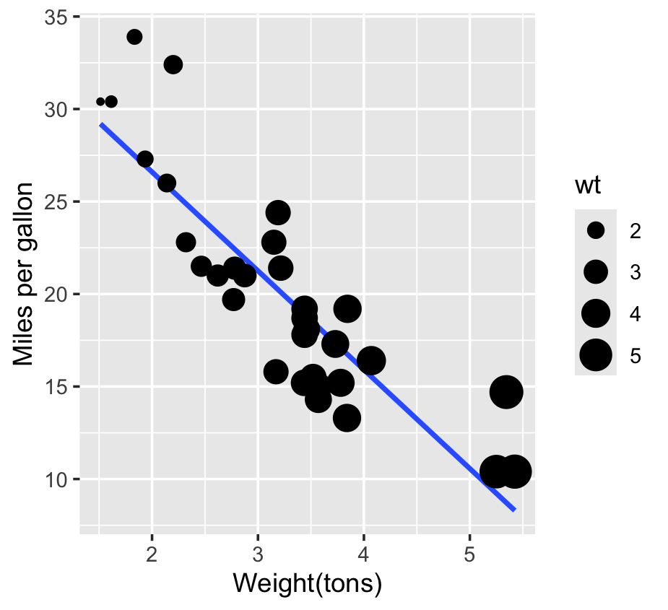

#adding different colors in graph
ggplot(mtcars, aes(x=wt, y=mpg)) +
geom_smooth(method = lm, se = FALSE) +
geom_point(aes(colour = hp)) +
xlab("Weight(tons)") +
ylab("Miles per gallon")+
scale_color_gradient(low = "green", high="grey")
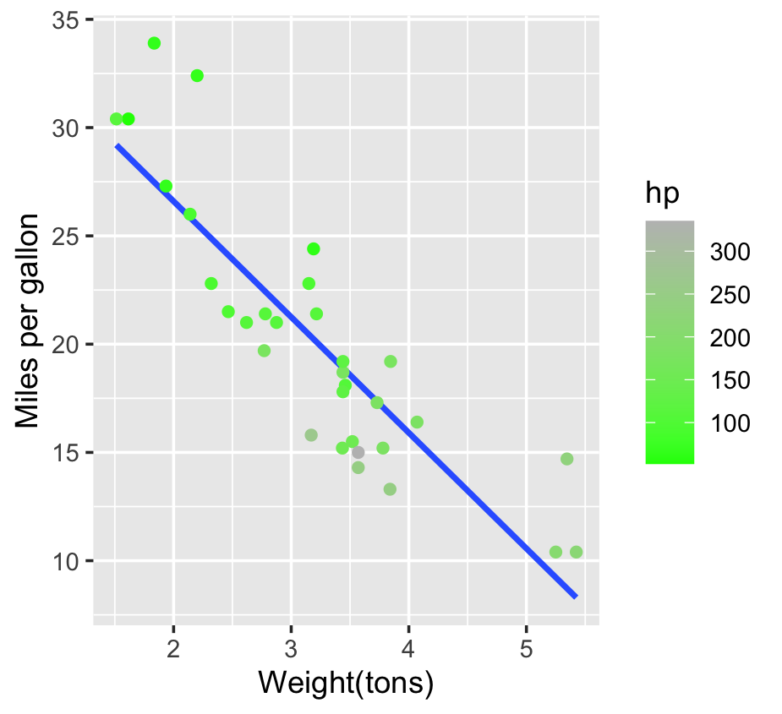

#boxplot
bull.richness <- read.csv("Bull_richness.csv")
ggplot(bull.richness,aes(x=GrowthStage, y=richness, colour = Fungicide)) +
geom_boxplot() +
geom_point(position = position_jitterdodge())+
scale_color_manual(values = c("orange","blue")) # to change color
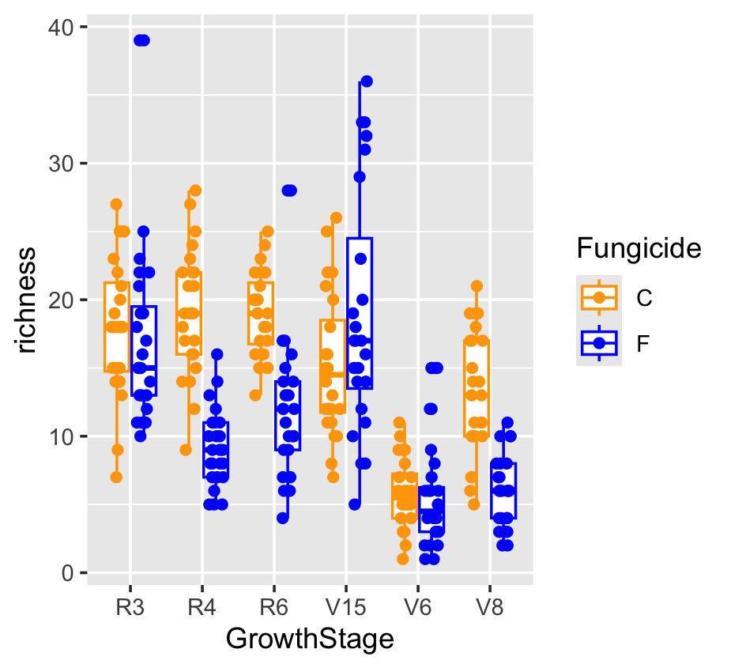

# Filling the color in boxplot
bull.richness <- read.csv("Bull_richness.csv")
ggplot(bull.richness,aes(x=GrowthStage, y=richness, fill= Fungicide)) +
geom_boxplot() +
geom_point(position = position_jitterdodge())+
scale_fill_manual(values = c("orange","blue"))
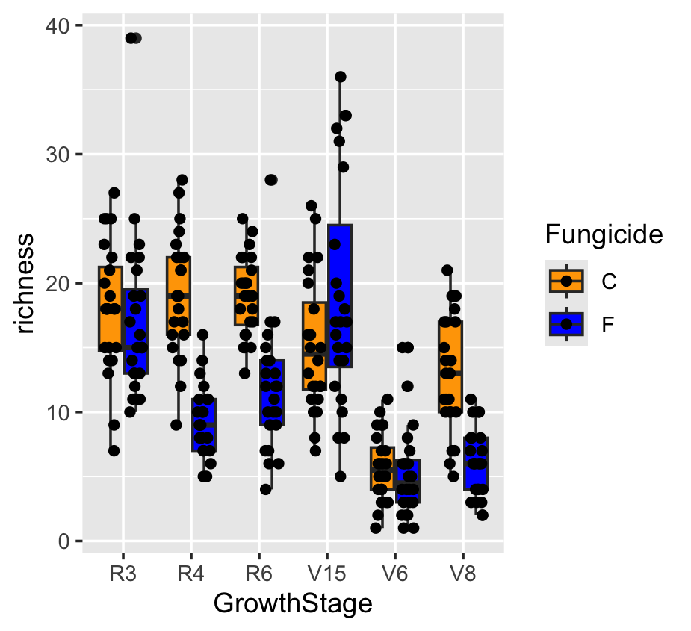

#Bars with SE
ggplot(bull.richness,aes(x=GrowthStage, y=richness, fill= Fungicide)) +
stat_summary(fun = mean, geom = "bar", position = "dodge")+
stat_summary(fun.data = mean_se, geom = "errorbar", position = "dodge")
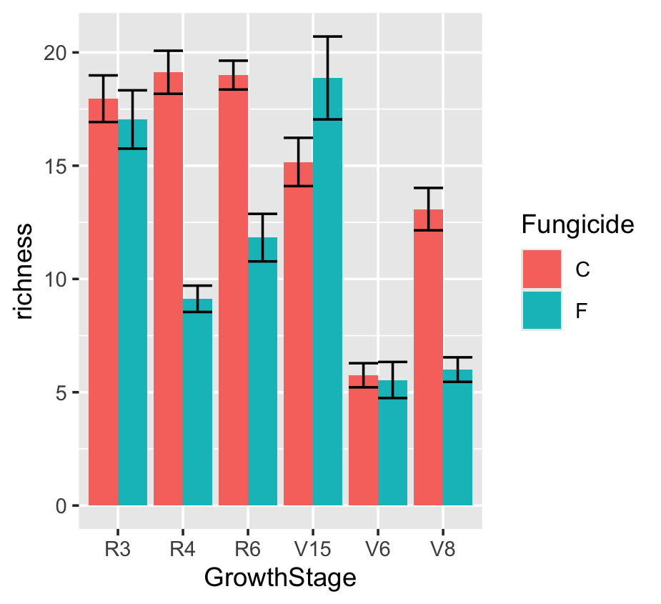

#Bars with confidence limit
ggplot(bull.richness,aes(x=GrowthStage, y=richness, fill= Fungicide)) +
stat_summary(fun = mean, geom = "bar", position = "dodge")+
stat_summary(fun.data = mean_cl_normal, geom = "errorbar", position = "dodge")
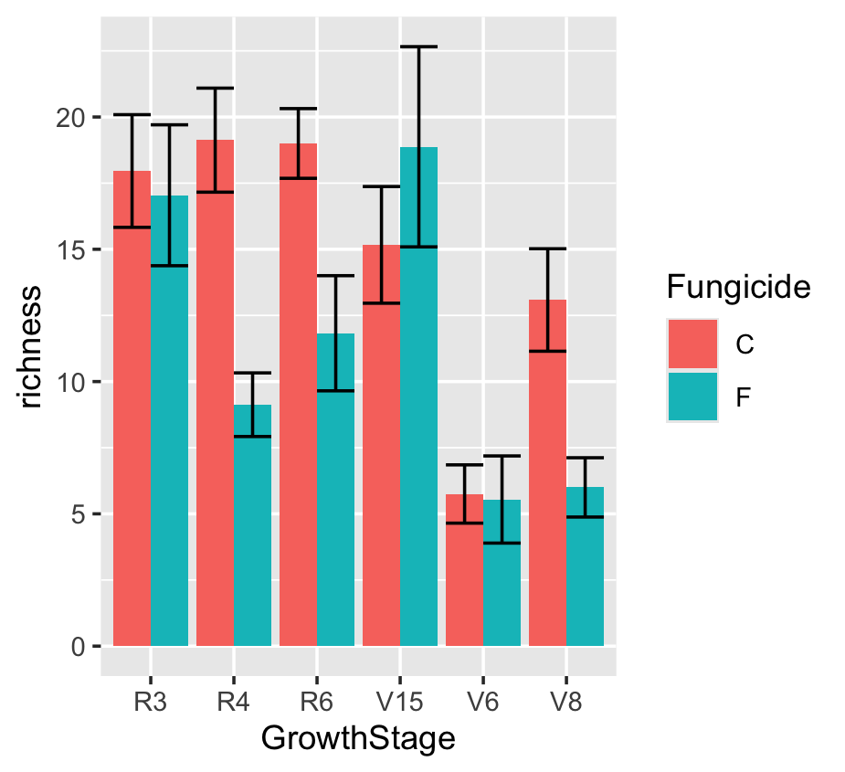

# only SE
ggplot(bull.richness,aes(x=GrowthStage, y=richness, fill= Fungicide)) +
stat_summary(fun = mean, geom = "line", position = "dodge")+
stat_summary(fun.data = mean_se, geom = "errorbar", position = "dodge")
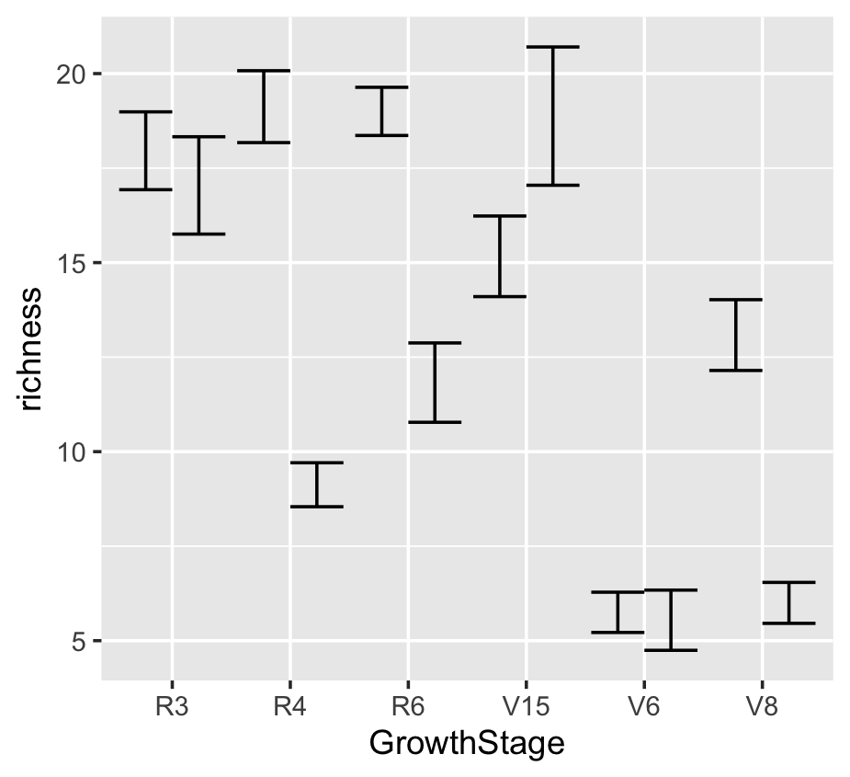

#line with SE
ggplot(bull.richness,aes(x=GrowthStage, y=richness, group= Fungicide, colour = Fungicide)) +
stat_summary(fun = mean, geom = "line")+
stat_summary(fun.data = mean_se, geom = "errorbar")
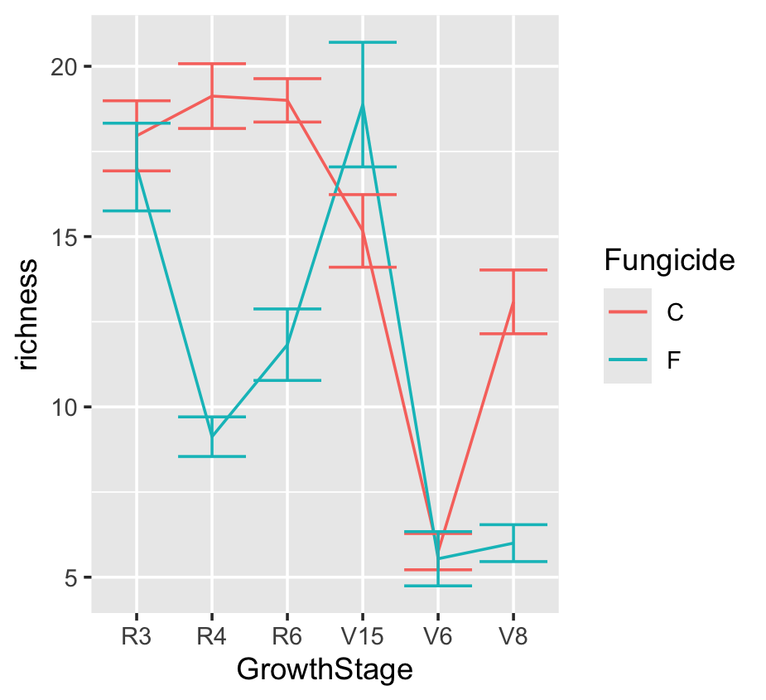

#facetting
ggplot(bull.richness,aes(x=GrowthStage, y=richness, group= Fungicide, colour = Fungicide)) +
stat_summary(fun = mean, geom = "line")+
stat_summary(fun.data = mean_se, geom = "errorbar") +
facet_wrap(~Treatment*Crop)

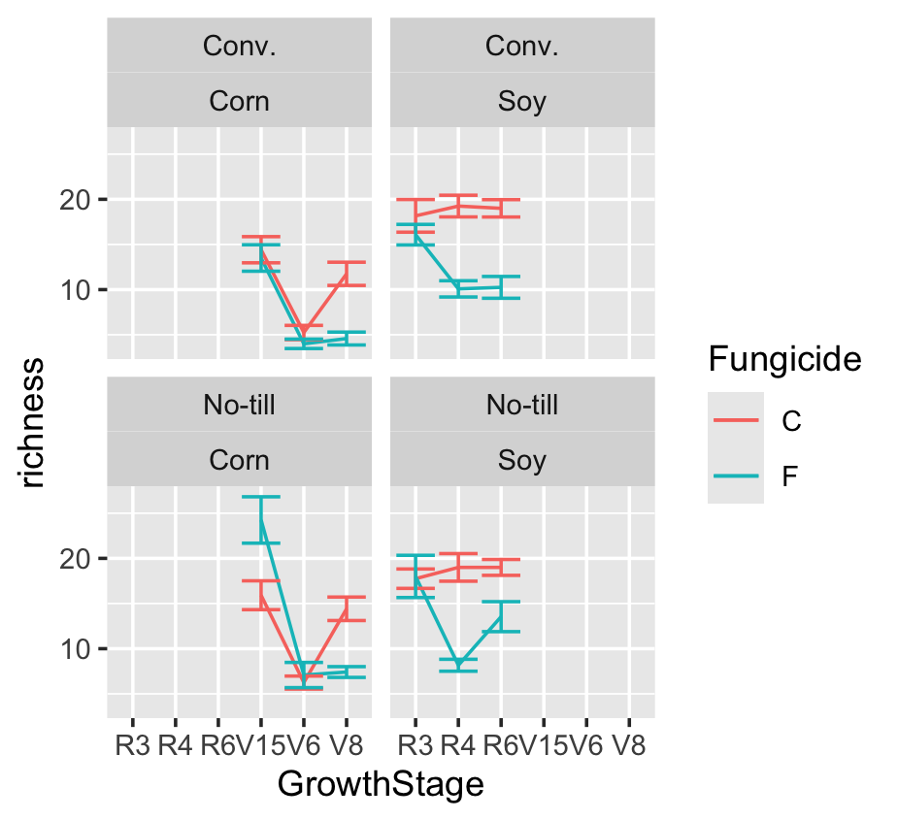

# Facetting with free scales
ggplot(bull.richness,aes(x=GrowthStage, y=richness, group= Fungicide, colour = Fungicide)) +
stat_summary(fun = mean, geom = "line")+
stat_summary(fun.data = mean_se, geom = "errorbar") +
facet_wrap(~Treatment*Crop,scale= "free")
